*Project Name [****HOTEL MANAGEMENT SYSTEM****]*

**Table of Contents:**

Chapter 01: **Introduction**

Chapter 02: **User Story**

Chapter 03: **ER Diagram**

Chapter 04: **SQL Query**

**Introduction**

Hotel Management System (HMS) is a digital platform that streamlines hotel operations through role-based access for admins, customers, staff, and receptionists. It automates bookings, payments, room assignments, and maintenance/leave requests via centralized databases. Features include real-time updates, secure transactions, and customized dashboards. The system enhances efficiency, reduces errors, and improves guest satisfaction, making it ideal for modern hospitality businesses seeking scalable, organized, and user-friendly solutions.

**Scenario Description**

The Hotel Management System (HMS) facilitates seamless interactions between guests and staff through automated workflows. When a customer makes a booking, the system verifies room availability, processes payments, and updates the booking status while marking the room as reserved. Staff members can report maintenance issues, which triggers alerts to administrators who assign tasks and track progress. Receptionists handle check-ins by verifying bookings and payments before updating room statuses, and manage check-outs by initiating cleaning procedures. Administrators oversee all operations, including approving staff leave requests to ensure proper staffing levels.

The system maintains real-time synchronization across all modules, from room assignments to payment processing, while enforcing role-based access controls. Automated notifications keep all stakeholders informed about booking confirmations, maintenance updates, and leave approvals. This integrated approach eliminates manual errors, reduces processing time, and enhances operational visibility across front desk, housekeeping, and management functions. The HMS optimizes resource allocation while improving both staff productivity and guest satisfaction through its responsive, user-friendly interface and centralized database management.

Key processes flow intuitively: customers easily browse and book rooms, staff promptly report and resolve issues, receptionists efficiently manage arrivals and departures, while administrators maintain comprehensive oversight. The system's intelligent design ensures all data - from room inventories to staff schedules - remains current and accessible to authorized personnel. By digitizing traditionally paper-based operations, the HMS establishes new standards for accuracy and efficiency in hotel operations, creating value for both guests and management through its reliable, transparent processes.

**ER Diagram**

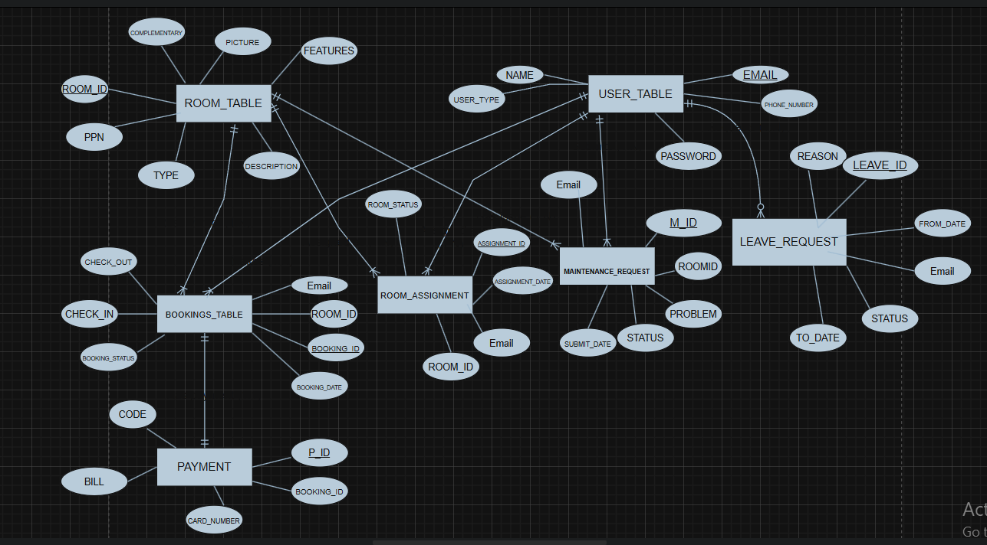

**Features List**

### ****1. User Authentication & Management****

* **Registration**: New users can sign up with name, email, phone, and password.
* **Login**: Role-based login (Customer, Receptionist, Staff, Admin).
* **Password Recovery**: Forgot password functionality via email and phone verification.
* **Profile Management**: Users can view and edit their personal information.

### ****2. Customer Features****

* **Room Booking**:
  + View available rooms with images, descriptions, and pricing.
  + Filter and sort rooms (alphabetically, price low-high, price high-low).
  + Select check-in/check-out dates.
  + Confirm bookings with payment.
* **Booking Management**:
  + View booking history.
  + Cancel bookings.
* **Payment**:
  + Secure payment processing.
  + Generate and download PDF receipts.

### ****3. Receptionist Features****

* **Booking Management**:
  + View all active bookings.
  + Update booking status (Booked → Check-In → Check-Out).
  + Remove bookings if needed.
* **Leave Application**:
  + Apply for leave with dates and reason.
  + View leave request history and status.

### ****4. Staff Features****

* **Room Assignments**:
  + View assigned rooms and cleaning status.
  + Mark rooms as cleaned.
* **Maintenance Requests**:
  + Report room maintenance issues.
* **Leave Management**:
  + Apply for leave and track approval status.

### ****5. Admin Features****

* **Dashboard Overview**:
  + View occupied rooms.
  + Track booking history.
* **Leave Request Handling**:
  + Approve or dismiss staff/receptionist leave requests.
* **Maintenance Management**:
  + Update maintenance request status (Pending → In Progress → Complete).
* **User Management**:
  + (Future) Add/remove users (staff, receptionists).

### ****Technical Features****

* **Database Integration**:
  + SQL Server for storing user data, bookings, rooms, etc.
* **Dynamic UI Generation**:
  + Rooms, bookings, and assignments displayed in dynamically generated panels.
* **PDF Receipt Generation**:
  + iTextSharp for creating payment receipts.
* **Role-Based Access Control**:
  + Different dashboards for customers, receptionists, staff, and admins.
* **Responsive Design**:
  + Adjusts UI elements based on screen size.

### ****Additional Features****

* **Room Details**:
  + View room images, amenities, and features.
* **Search Functionality**:
  + Search rooms by type.
* **Date Validation**:
  + Prevents booking conflicts by checking room availability.

**UML Diagrams**

**Activity Diagram :**

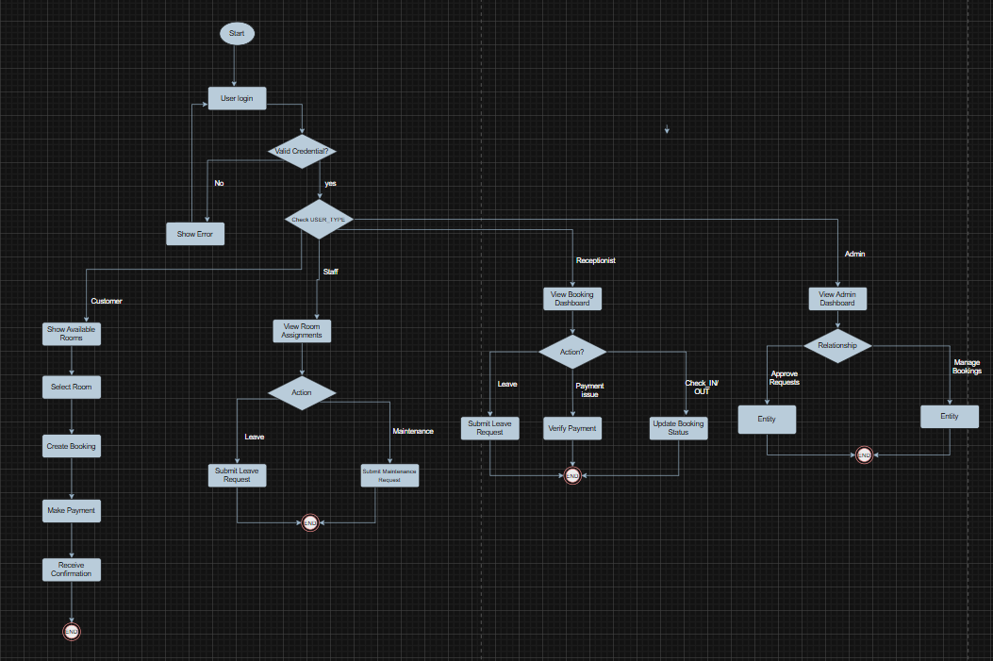

Use Case Diagram :

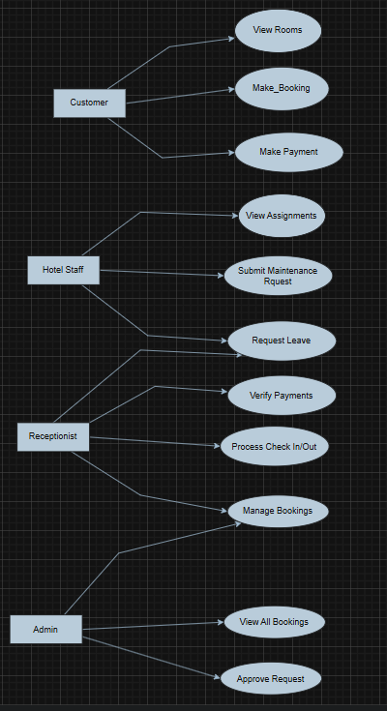

**Schema Diagram**

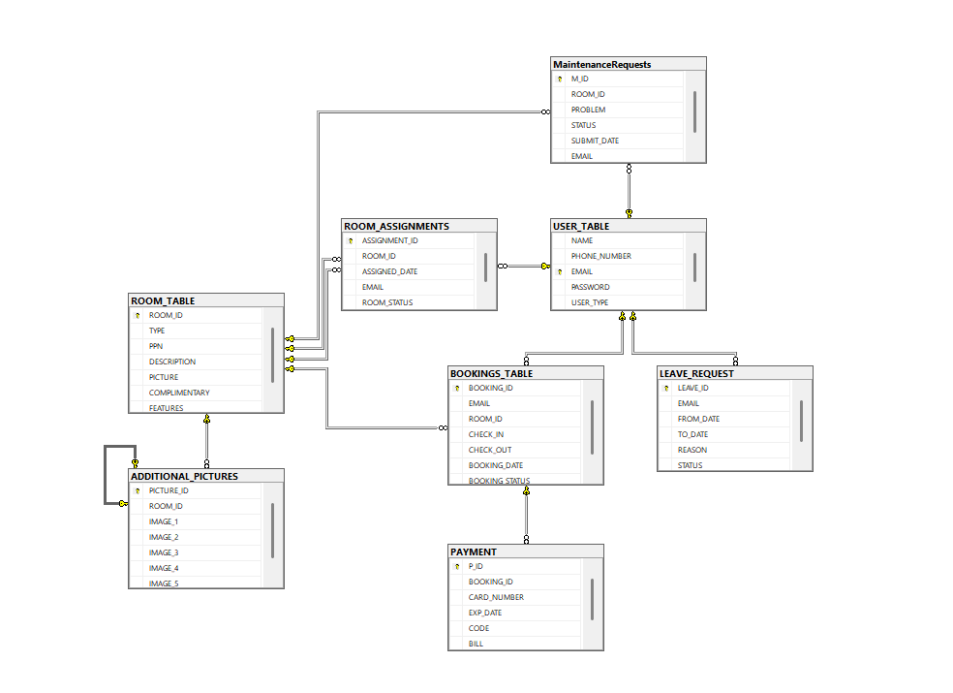

**Conclusion**

This hotel management system efficiently streamlines operations for customers, staff, receptionists, and administrators. With secure authentication, dynamic booking, payment processing, and role-based dashboards, it enhances user experience and operational efficiency. The system ensures smooth coordination between departments, improving service quality and management. Future enhancements could include AI-driven recommendations and mobile app integration for greater accessibility.